Write a python program for Natural Language processing which performs chunking

import nltk

new="the big cat ate the little mouse who was after the fresh cheese"

new_tokens=nltk.word_tokenize(new)

print(new_tokens)

new_tag=nltk.pos_tag(new_tokens)

print(new_tag)

grammer=r"NP:{<DT>?<JJ>*<NN>}"

chunkParser=nltk.RegexpParser(grammer)

chunked=chunkParser.parse(new_tag)

print(chunked)

chunked.draw()

OUTPUT

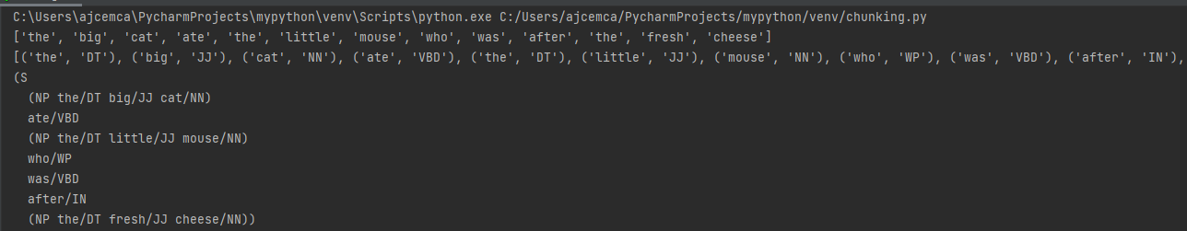

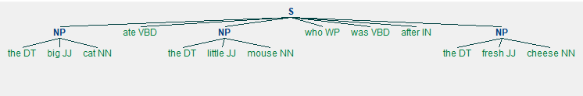

import nltk

sample_text="""

Rama killed Ravana to save sita from Lanka.The legend of Ramayan is thr most popular

Indian epic.A lot of movies and serials have already been shot in several languages here in Indaia based on ramayana.

"""

tokenized=nltk.sent_tokenize(sample_text)

for i in tokenized:

words=nltk.word_tokenize(i)

tagged_words=nltk.pos_tag(words)

chunkgram=r"""VB:{<DT>*<NN>?<JJ>}"""

chunkParser=nltk.RegexpParser(chunkgram)

chunked=chunkParser.parse(tagged_words)

print(chunked)

chunked.draw()

OUTPUT  
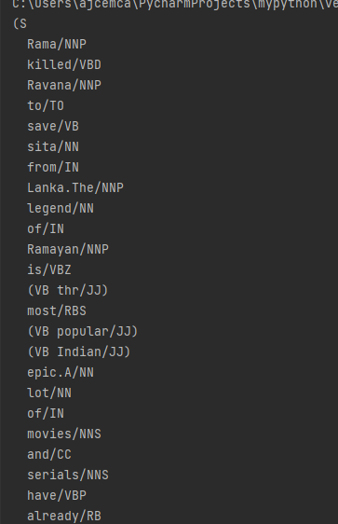

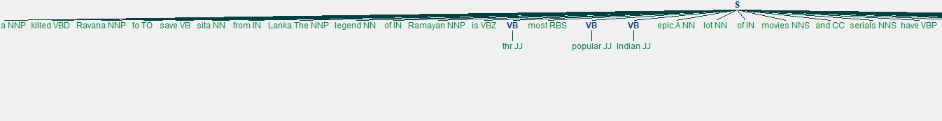

import scrapy

class Quotesspider(scrapy.Spider):

name = 'quotes'

def start_requests(self):

urls=['http://quotes.toscrap.com/page1/'

'http://quotes.toscrap.com/page2/']

def parse(self, response):

page=response.url.split("/")[-2]

filename='quotes-%s.html'% page

with open(filename,'wb')as f:

f.write(response.body)

self.log('saved files%s'%filename)

print( response.body)